 | St Patrick of the Island |  |  |  | Parish Bulletin
week of april 1, 2018 – Easter Sunday
masses  saturday march 31, 2018  7:30pm Muriel & Herve Bertrand from family  sunday april 1, 2018  9 am Ed St. Amand from Marc & Gary  11am Helen Bulger from Mary Martin  wednesday april 4, 2018  4:30pm Priest’s Intention  friday april 6, 2018  9:00am Sacred Heart in Memory of Dick, Doris & Holy Souls  saturday april 7, 2018  7:30pm Blessed Virgin in Memory of Dick, Doris & Holy Souls  sunday april 8, 2018  9 am Intention of the Parishioners  11am Thelma Gonsalves from Rod & Jean MacDonald  this week’s eucharistic ministers  5pm: Gerry & Andrew  9am: Angie & Anne  11am: Frances & Mary  the sanctuary lamp burns for:  This week: Special Intention of the Cordeiro Family  Next week: Special Intention of the Cordeiro Family |  | COLLECTION  The collection for March 25th was $1856. Thank you for your contributions.  roof fund collection  Our monthly collection for the Roof Fund will take place next weekend. Please be generous.  FAITH EDUCATION  There is a meeting for the parents whose children are making their First Communion on Sunday April 8 at 10am, in the church.  On Sunday April 15th, at 10am, there is a church tour for Miss Angie’s and Miss Nancy’s students.  PLEASE PRAY FOR:  Caroline & Patrick, Peter Morahan, Ginny Bannasch, Isobel Agnew, Dave Currie, Phyllis Bird, Dolores Sandy, Mary Martin, Marie Hulse, Andria MacDonald, Jean Clifford, Gabrielle McWilliams, Karen Descoeurs, Mary & Marian Lapchak, Caiti Dore, Helen Lariccia, Eva Bideau, Catherine Shea, Lucie Cardinal, Rod Desmarais, Frank McCluskie, John Battaglia, Ben, Linda Panaro, Boleslaw Zugda, Betty, Gerry & Mary Guy, Ann Desmarais, Thomas Gillette, Elaine Kerr, Woody Leclerc, Jean Gauthier, Brian Lang |  |  | Spaghetti Supper  The KofC will be hosting their annual Spaghetti Supper on April 7th at 6 pm. The children of our parish will be performing for your entertainment! There will be a cash bar and door prizes. Tickets are $15, $6 for children 6-12 and free for children under 6. Tickets will be available after Mass. For information contact Arnold Hoffman at 514-425-1066 or Tony Grynczuk at 514-453-5072.  Bishop’s Dinner  The annual Bishop’s Dinner will be held on Wednesday April 11th at 6:30 pm at the Ile Perrot Community Center. Tickets are $60 and are available at the office.  PARISH BANNER  We have been invited to create a Parish Banner for the 125th Anniversary. We are asking for your ideas, eg: what does the parish mean to you - a phrase, symbol, an event or ??? If you have an idea, please contact Anne, Anita or the office.  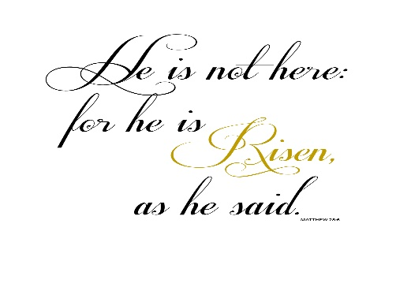 | EASTER REFLECTION  Today we begin the Easter Season, our 50-day meditation on the mystery of Christ's Resurrection. Our Gospel today tells us about the disciples' discovery of the empty tomb. It concludes by telling us that they did not yet understand that Jesus had risen from the dead. The details invite us to reflect upon a most amazing gift, that is faith in Jesus and his Resurrection.  Each of the four Gospels tells us that Jesus' empty tomb was first discovered by women. This is notable because in first-century Jewish society women could not serve as legal witnesses. Mary is simply said to have observed that the stone that had sealed the tomb had been moved, and she runs to alert Simon Peter and John. Her statement to them is telling. She assumes that Jesus' body has been removed, perhaps stolen. She does not consider that Jesus has been raised from the dead.  Simon Peter and John race to the tomb, to verify Mary's report. John arrives first but does not enter the tomb until after Simon Peter. This detail paints a vivid picture, as does the detail provided about the burial cloths. Some scholars believe that the presence of the burial cloths in the tomb offers evidence to the listener that Jesus' body had not been stolen (it is understood that grave robbers would have taken the burial cloths together with the body).  Our Easter faith is based on their witness to both the empty tomb and their continuing relationship with Jesus—in his appearances and in his gift of the Holy Spirit.  –Loyola Press

