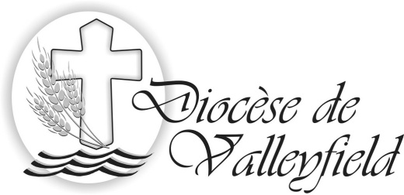

Salaberry-de-Valleyfield, June 11, 2014 - We are sending you a pastoral letter of our Bishop, Noel Simard, dated June 11, 2014, concerning the implementation of the Pastoral Units in the diocese.

We would appreciate it if you could make your parishioners aware of this diocesan direction as soon as possible, preferably this weekend. We will be holding a press conference on Monday, June 16 at 11:00 at the Diocesan Centre to present the fruits of the reflections and consultations we have undertaken ove the past several months, and which were conducted to develop this model of church life and to proclam the gospel in our diocese.

Thank you for your faithful collaboration.

--------------------------------

Summary for your parish bulletins of the Pastoral Letter of Bishop Noel Simard:

After addressing the present situation of our diocesan Church with its great challenges and its great hopes, and taking account of both external and internal causes, Bishop Simard puts forth the urgency of a “pastoral conversion which calls for our solidarity in communion and fruitfulness of mission”. To be Church Differently demands that we focus on what is essential and that we join our efforts to respond properly to the mission which Our Lord assigns to us.

The organization of PASTORAL UNITS in the diocese, like those in many other dioceses in Quebec, consists of a grouping of parishes and a communion of communities. In a pastoral unit, the parishes maintain their administrative identity, and thus the fabriques continue to exist; nevertheless, one single pastoral team will take care of the entire unit for which it has pastoral responsibility. The make-up of each team will differ from one unit to another but will include, without fail, the presence of a priest and lay persons known within the community or mandated by the Bishop. This is in conformity with the establishing of pastoral animation teams from within (EPAM) and the parish and pastoral advisories (C.P.P.)

The permanent presence of a priest in each Christian community is no longer possible; it is therefore necessary, where it is feasible, to name a delegated person from the community who will act as the bridge between the pastoral team and the congregation of the faithful, in connection with the lived experience of the region and of the diocese. The engagement and the participation of the baptized are indispensible for breathing into the Christian communities a life force and a spiritual and missionary dynamism.

“TOGETHER, turned toward the future, let us take up the challenges attached to the new ways we are seeking. With joy and confidence, rooted in the Word of God, let us witness to Jesus in our world and give it the savor of the knowledge of Christ and loving Him. Let us be a missionary Church which reveals to our brothers and sisters the tender face of God and the beauty of the gospel which generates for each epoch the ways of goodness and fulfilment.

Let us be Christian communities filled with hope, with faith and with love, open to the surprises of the Spirit, joyous to make resplendent the treasure of the gospel to all those towards whom the Lord sends us.”

