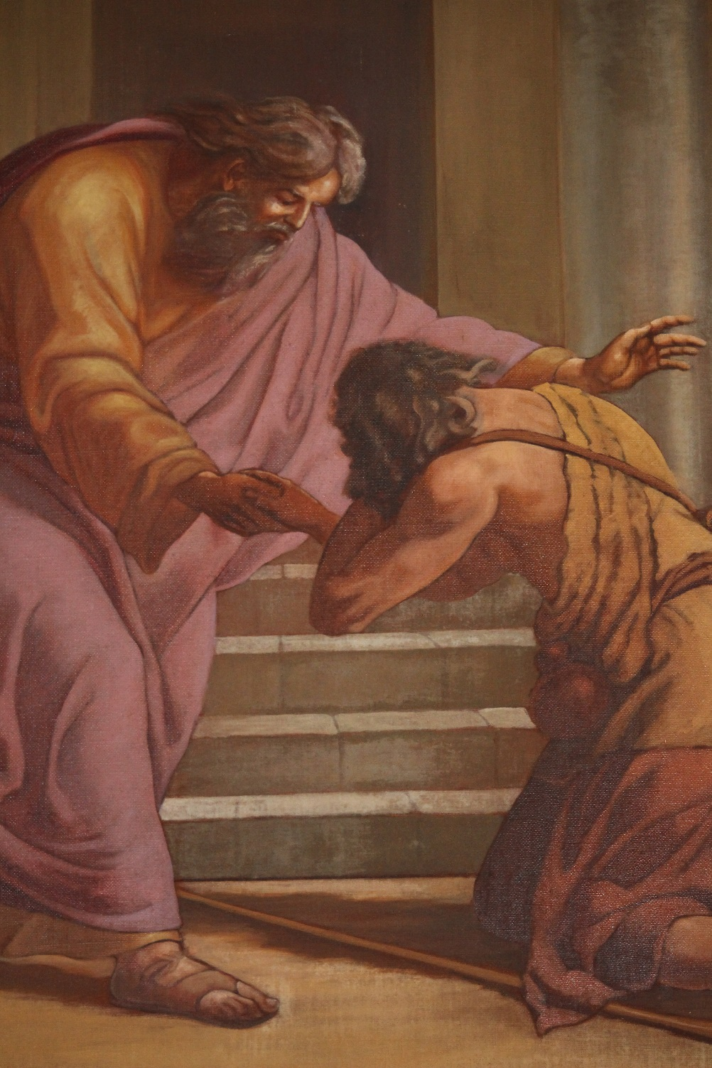

Pastoral Letter
From His Grace Noël Simard
Bishop of Valleyfield

ABOUT THE SACRAMENT OF FORGIVENESS

PASTORAL LETTER FROM HIS GRACE SIMARD, BISHOP OF VALLEYFIELD, ABOUT THE SACRAMENT OF FORGIVENESS

To the pastors and the faithful of the diocese of Valleyfield
Greetings and blessings in the Lord

Since my arrival in the diocese of Valleyfield, many pastors, deacons and pastoral agents have asked me to give my opinions on the sacrament of forgiveness or for some, on the forms that this sacrament can take. Other people expressed their wish for a deep reflection about this misunderstood, neglected sacrament. Indeed we observe an alienation in many Catholics for this extraordinary sign of tenderness and mercy from God.

For that matter, Pope Francis has been constantly coming back to this sacrament for months, whether in his daily sermons or in catechesis given during an interview on St. Peter Square. But Pope Francis isn’t just talk; he acts. This is why, for the “24 hours for the Lord” of March 28th and 29th 2014, he gave an extraordinary example of humility and Christian life by confessing in public, to a priest. He wanted to highlight the value of a sacrament that has fallen into relative disuse and encourage believers, including priests, deacons and bishops, to rely on the sacrament of reconciliation or forgiveness more often. It is still one of the goals of the extraordinary Jubilee of mercy to value forgiveness and its sacramental form, as Pope Francis affirms in his Bull of Indiction of the Jubilee:

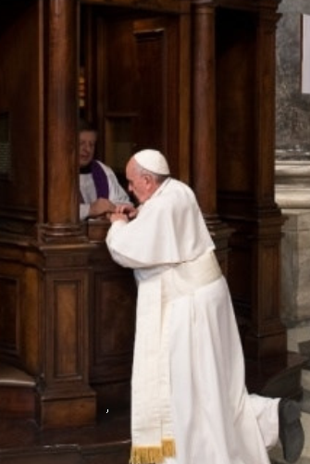

“The time has come for the Church to take up the joyful call to mercy once more. It is time to return to the basics and to bear the weaknesses and struggles of our brothers and sisters. Mercy is the force that reawakens us to new life and instills in us the courage to look to the future with hope. (N° 10).”

“Let us place the Sacrament of Reconciliation at the center once more, in such a way, that it will enable people to touch the grandeur of God’s mercy with their own hands. (N° 17).”

Osservatore Romano

I ─ THE MEANING OF THE SACRAMENT OF FORGIVENESS

- Before talking about the sacrament that has constantly been misunderstood in the history of the Church, it is relevant to clarify the language. Why does this sacramental sign in which the Lord keeps manifesting His mercy and forgiveness have such different names: confession, penitence, forgiveness, reconciliation? Some catechists even talk about the sacrament of peace. Everything depends on the emphasis we want to give the sacrament.

“Confession” insists on a sincere admission of our faults and the sins we have committed.
“Penitence” denotes, the change, conversion and reparation for wrongdoings or offenses.

“Reconciliation” demonstrates, that it is God, who waits for us to reconcile with Him and who gives the one seeking God’s forgiveness the strength to reconcile with God himself, with the Church, their sisters and brothers and even with nature.

Finally “forgiveness” reminds us that it is God, through his Son, who was crucified and has risen, and through the mediation of the Church and a priest, who forgives us and gives us the strength to “forgive those who have offended us”, as is asked of us, in the Lord’s Prayer

The expression of God’s mercy

- To understand the sacrament of forgiveness, you must first situate it in the context of God’s mercy. It is thanks to St. John Paul II that mercy was put back at the center of our teaching and our Christian life with the publication of the encyclical “Dives in Misericordia” on November 30th 1980. Mercy is urgent nowadays. Indeed, the conflicts in our families, our societies, the world, the acts of terrorism, the violence, the massacres that have happened in the last few months, call out to us and remind us that only mercy can resolve these situations. Isn’t that what John Paul II reminded us :

“Christ pours out this mercy on humanity though the sending of the Spirit who, in the Trinity, is the Person-Love. And is not mercy love's "second name" understood in its deepest and most tender aspect, in its ability to take upon itself the burden of any need and, especially, in its immense capacity for forgiveness?” (Homily for the canonization of Sister Maria Faustina Kowalska).

- Too often we present the forgiveness of God as some vague condescension of the Creator towards the mistakes of His creatures. Of course, human beings have sinned: let’s wipe the slate clean! The forgiveness of God would be, at worst, contempt, in most cases, indifference, and at best, forgetfulness: “Let’s not talk about it anymore! It’s in the past!” It is badly misunderstood that God’s forgiveness is only an expression of his mercy. Of his infinite mercy: it remains like the face of God, like the revelation, the manifestation of his most intimate nature. God is mercy and what is asked of us, is to touch the heart of God, by calling out to his mercy, to his love.

- Welcoming the forgiveness of God, is celebrating his mercy with joy which renews us. It is what the parables of mercy are telling us, that is to say the parable of the lost sheep, of the lost coin and the one about the merciful father or the prodigal son (Luke 15). It is difficult to enter into this big movement of mercy and to adopt this form of love that pushes us to live others’ misery as though it were our own. But, without mercy, there is no reconciliation possible. The Church received the mission from Christ to witness to God’s mercy. When we question in the New Testament, the foundation of the Church, its mission, the sending of the Apostles and the disciples, it is to forgive, to bring to reconciliation. Saint John clearly affirms that the apostles received the power to forgive sins: “Receive the Holy Spirit! Those to whom you forgive their sins, they will be forgiven” (John 20: 22).
In his catechesis on forgiveness (February 19th 2014), Pope Francis reaffirm this conviction:

“This passage reveals to us the most profound dynamic contained in this Sacrament. First, the fact that the forgiveness of our sins is not something we can give ourselves. I cannot say: I forgive my sins. Forgiveness is asked for, is asked of another, and Confession we ask for forgiveness from Jesus. Forgiveness is not the fruit of our own efforts but rather a gift, it is a gift of the Holy Spirit who fills us with the wellspring of mercy and of grace that flows unceasingly from the open heart of the Crucified and Risen Christ.”

- In his Second Letter to the Corinthians, Saint Paul defines his ministry as “We are therefore Christ’s ambassadors of reconciliation” (2 Co 5:20), a ministry he will exercise by putting in a lot of effort to reconcile brothers separated by a conflict or by divided communities. Our affiliation to the Church makes us “people of reconciliation” destined to testify to the world that forgiveness is possible, invested in this mission to announce, in words and in actions, this Good News of the mercy of God revealed in Jesus Christ. And as it is so well said by Pope Francis,

“Dear friends, celebrating the Sacrament of Reconciliation means being enfolded in a warm embrace: it is the embrace of the Father’s infinite mercy.” (Catechesis, February 19th 2014).

To open oneself to God’s forgiveness which is a hopeful strength, it’s inevitably engaging in a process in which we recognize the reality of sin in our existence.
The meaning of sin

- It must be noted that the meaning of sin is lost in our world and among the faithful. Or, as Saint John Paul II reminds us:

“This sense is rooted in man's moral conscience and is as it were its thermometer. It is linked to the sense of God, since it derives from man's conscious relationship with God as his Creator, Lord and Father.” (Reconciliation and Penance, n° 18).

The obscuring or eclipse of consciousness leads to the loss of God’s meaning and a diminishing of the meaning of sin. We could also say that the loss of the meaning of sin is the result of the negation of God. If, in the past, we saw sin everywhere, maybe today we do not see it anywhere.
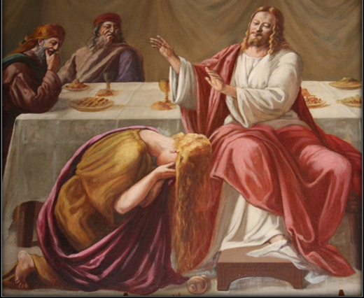

Sin is not first a moral problem, but a theological problem. It is refusing God, excluding God from our life, exclusion that, nowadays, does not manifest itself by rejecting God but by being indifferent to Him. Sin is not our moral faults or our foolishness but it is refusing God, the refusal to be in a loving communion with God and others.

- Always accessible from God, divine life cannot flow in us and between us because it is blocked by our actions, our words or our way of being and living. Sin is a lack of love that breaks the relationship between God and a person. We are all sinners but we must recognize ourselves as sinners, which can only happen if we become fully aware of the love God has for us and our penury.

- Our contemporaries talk of sacrosanct freedom and personal autonomy. But when freedom is searched for apart from God, we find ourselves confronted by a loss of personal dignity, by a moral confusion and social disintegration. Rediscovering the meaning of sin and of its destructive power both on a personal and social level is a service of hope: It is to empower the faithful in their struggle against evil and sin and in their choice for the perfection of love and the fullness of Christian life. It is good to hear Pope Francis’ tell us again, that we recognize that we are all sinners:

“Who among us can presume not to be a sinner? No one. We are all sinners […] to speak always the truth and avoid all deceit; not to steal, but rather to share all you have with others, especially those in need; not to give in to anger, resentment and revenge, but to be meek, magnanimous and ready to forgive; not to gossip which ruins the good name of people, but to look more at the good side of everyone. It is a matter of clothing oneself in the new man, with these new attitudes.” (Saint-Peter Square, “24 hours for the Lord”, March 28-29 2014).

The privileged place of reunion
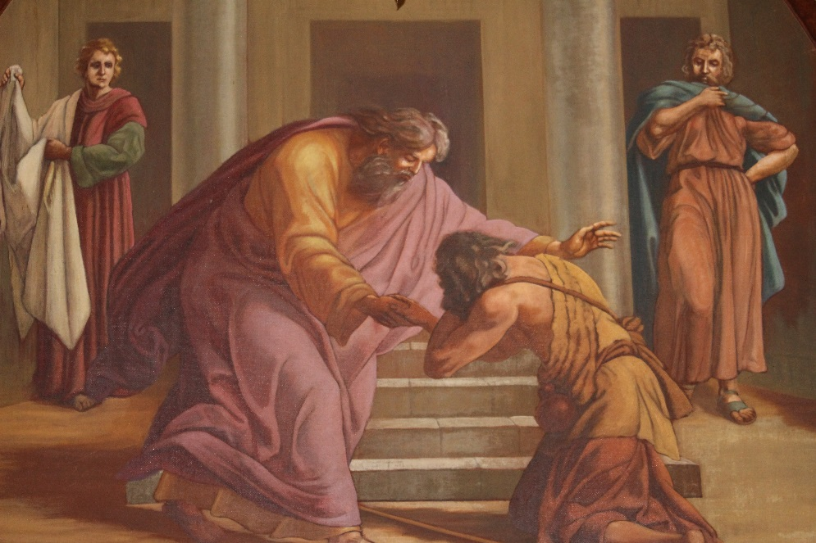
- In one of his books, René Dufay compared the sacrament of forgiveness to a “house where I am awaited” (La maison où l’on m’attend, Ed. Chalet, 1975). Referring to the parable of the merciful father or the prodigal son, he shows that in the house, there is a loving father waiting for the return of his son, who pronounces the liberating words which spring from the silent patience of merciful love and is also expressed by the race towards his son, arms open wide and an embracing heart.

There is the son who squandered his father’s goods but who comes back, who crosses the threshold of the house. If the initiative of reconciliation comes from the Father, it is only possible by a “turnaround” of the son who decided to turn away from his degenerate situation and put himself on the road home. The son did not resign himself to obscurity. This son confesses his sin and asks to be treated like a servant: this is the mature confession of someone with an experience that leads him to the truth.

- It is the examination of conscience that must be viewed through the eyes of Jesus to look at our life and the world renewed by the Word of God:
- Gaze of tenderness and amazement before creation, the wonderful being that I am, the liberating achievements of humanity, the numerous signs of the loving presence of God, etc.
- Gaze of sadness and disappointment before the waste and pollution as much in nature as in the heart, before the injustices, the rejections of love, and the indifference…;
- Gaze of confidence and hope before “the mornings that ceaselessly return and the springs that are tirelessly reborn” (René Dufay, La maison où l’on m’attend, p. 21). And it is when he is in the arms of his Father that the son abandons his enslaved soul of servitude and gets back his dignity as a son, a sinner, forgiven. He is then reconciled within himself.
- To recognize oneself as a sinner, is to see oneself as a guilty person, guilty but loved, capable of identifying every page of our life, “the beautiful pages to glorify them as they were occurrences of success and human dignity, the ugly ones to glorify too as they were occurrences of truth and forgiveness” (René Dufay, p. 132). To recognize oneself as a sinner is, in other words, to accept oneself, one’s life, the gaze of a God awaiting not to condemn us, but to liberate us, to take our hand and tell us again of his love. When we begin our confession by this formula: “Bless me Father, for I have sinned”, we are not in error; to the contrary, we are already expressing our conviction of both God’s goodness and the malice of our sin.

- There is also the older brother who must cross the threshold of the house. While the youngest son experiences loss and failure, the big brother experiences sin, experiences the numbing of the heart. Clinging to his rights, he refuses to welcome his brother. It is a question of reconciliation. There too, it is the Father who goes out to “plead” with his son to come in to share the joy of reuniting with the lost son. To let oneself be reconciled, it is also accepting to look upon the other with a gaze other than our own; it is espousing the eyes of God that re-establish friendship with our brother or sister. It is accepting that someone intervenes to indicate to us that the person whom I am hostile towards or do not understand cannot be reduced to the image I have of them. It is laying the benevolent eyes of God upon all our brothers and sisters without exception: that woman, that man, these people from another race, from another country or another leaning, these people that I don’t like or like badly, God loves them.

- Finally in the house, the household takes its place. It is all the people who work to organize a party, who welcome others, who take out the cutlery, who make sure there is music, in a word who share the joy of the father. Thus the sacrament of forgiveness cannot be reduced to a simple individual meeting; it demands the community dimension of a sign true to this loving Alliance that God signed with his people. To let oneself be reconciled, is accepting to join the household to share the joy of a reconciled family, the joy of the assembled Christian community. The sacrament of forgiveness places us back in communion with the Church of those redeemed in Jesus Christ. This is why the sacramental reconciliation is necessarily ecclesial: it is made visible and palpable in the Church, a privileged place of action, of the presence and the reception of God, a place of reunion. And in this house, within the household, people have been chosen, organized, to speak the words of reconciliation, the Word of mercy, and to be “signs” themselves, making the presence of Christ visible. The absolution that the priests denote in the name of Christ is the word of resurrection, of renewal, of fertile love.

- If we want the sacrament of forgiveness to find its place in our heart, we must give people the desire to enter into the house and to join the household reunited in one loving, joyful heart. It is the responsibility of our parishes, our Christian communities to be “islands of mercy” (Pope Francis), welcoming houses of peace, lighthouses that can be seen from afar when we are lost, houses where everyone can feel at home, even the publican, the marginalized, the person living on the fringes of society or our hearts.

The sacrament as a place of healing

- In his catechesis on the sacrament of forgiveness on February 19th 2014, Pope Francis put an emphasis on the healing dimension of the sacrament:
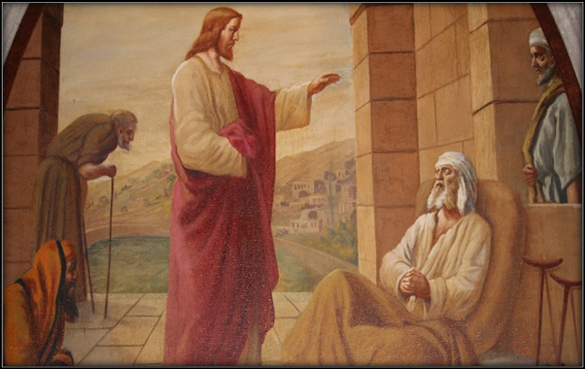

“The Sacrament of Reconciliation is a Sacrament of healing. When I go to confession, it is in order to be healed, to heal my soul, to heal my heart and to be healed of some wrongdoing.”

And the Pope referred to the episode of forgiveness and healing of the paralytic man (Mk 2: 1-12; Mt 9: 1-8; Lk: 17-20) when the Lord reveals himself to be both a doctor of the soul and the body.

It is not surprising that Pope Francis compares the Church to a field hospital in the service of those wounded by life, a now established phrase spoken during his meeting with the roman clergy on March 6th 2014. Speaking to the priests, he reminds them how they must be men of mercy and welcome the penitents with the “loins” of mercy of the Lord:

“Priests are moved to compassion before the sheep, like Jesus, when he saw the people harassed and helpless […]Thus, in the image of the Good Shepherd, the priest is a man of mercy and compassion, close to his people and a servant to all […]The priest reveals a heart especially in administering the Sacrament of Reconciliation; he reveals it by his whole attitude, by the manner in which he welcomes, listens, counsels and absolves […]The truly merciful priest behaves like the Good Samaritan […]Because his heart is capable of having compassion, it is the heart of Christ!”
II ─ MANY FORMS, THE SAME SACRAMENT

- The Rite of the sacrament of penitence and reconciliation suggests many forms of celebration of the sacrament of forgiveness: individual or communal. The most common forms are individual reconciliation and the communal celebration with individual absolution. There is also the communal celebration with collective absolution that can only happen if conditions of grave necessity are applicable and if it is approved by the bishop. Each of these forms puts an emphasis on an aspect of the sacrament, to which we want to give priority or not.

- The individual celebration “permits, in an irreplaceable manner, that forgiveness touches everyone in the most personal way” (Rite, n° 26). This form gives more importance to the confession of the penitent and to the word of encouragement and mercy of the priest. It also opens the possibility of a dialogue with the penitent and of a realistic penance or reparation adapted to the person who confesses. For this form to favor conversion and commitment of faith and charity, it must take into consideration the necessity of listening and sharing the Word of God. The penitent must reread their life not from a list of sins, but from the Word of God.

- The community celebration highlights the ecclesial dimension of the sacrament and the necessity to reconcile ourselves with each other. It also expresses that we are hurting together and that the wounds of sin affect us all. It is an occasion to ponder our relationship with the world and our environment, our lifestyle in Church, our efforts to live social justice and service to the poor and destitute. To recognize ourselves as sinners together becomes a prophetic act that announces to the world the salvation of God and his alliance with us. This form allows the edification of the Church as a community of baptised, reconciled, forgiven sinners, loved and anxious to live the gift of God’s grace.

Pope Frances tells us: “Over time, the celebration of this Sacrament has passed from a public form — because at first it was made publicly — to a personal one, to the confidential form of Confession. This however does not entail losing the ecclesial matrix that constitutes its vital context. In fact, the Christian community is the place where the Spirit is made present, who renews hearts in the love of God and makes all of the brethren one thing in Christ Jesus. That is why it is not enough to ask the Lord for forgiveness in one’s own mind and heart, but why instead it is necessary humbly and trustingly to confess one’s sins to a minister of the Church.” (Catechesis about the sacrament of reconciliation, February 19th 2014).

In this sentence, Pope Francis affirms both the ecclesial and individual dimensions of the sacrament of forgiveness. It is not inadvisable to ask oneself if we must value all the forms of the sacrament again. If the Church wanted them pluralist, is it not to develop all the facets and all the riches of the sacrament.

- The usual way of receiving the sacrament of forgiveness remains the individual meeting with the priest. Hence we must make it accessible and rely on it with trust.

However, some peculiar and exceptional circumstances can allow the community celebration of forgiveness with a collective absolution or an individual absolution and global confession. These circumstances, once identified, must be left to the bishop’s sound judgement.

Finally, to these sacramental forms we add the usual methods of forgiveness suggested by the Church throughout its rich history: the practices of charity, of fasting and of prayer specifically encouraged in Lent, the corporal and spiritual works of mercy that Pope Francis spoke about in his bull of indiction about the Jubilee of mercy (n° 15), the fight for peace and justice, service to our neighbor, the acceptance of suffering and the offering of difficulties in life, etc. We cannot forget the celebration of Eucharist, the ultimate place of reconciliation and forgiveness for most daily breaches.

In this jubilee year of mercy, I invite all diocesan members to make a pilgrimage to Sainte Cecile Cathedral-Basilica and to cross the threshold of the door of mercy.

- I encourage all Christian communities to value this sacrament of the mercy of God by exploring all its riches, its facets and its dimensions. This is why we must think about catechesis concerning the meaning of forgiveness and sin, and about the confession of our faults. These catecheses are not only aimed at youth and catechumens, but also our older people.

- To take example from Pope Francis, I advise pastors to frequent this sacrament and to be accessible to offer this indispensable pastoral service for the good of the hearts and the spiritual growth of our Christian communities. It is a rendezvous with a compassionate and merciful Christ that is given to us to heal our hearts and work on the healing of the wounds of the world. Reconciled and forgiven, we will be able to communicate to others the joy of welcoming God’s forgiveness and to rediscover a love and unity with our brothers and sisters.

And most particularly in this jubilee year of mercy and in this season of Lent 2016, let’s tell them that the house of the Father awaits them, that it is open to welcome them and to offer them the forgiveness of God.

Given at Salaberry-de-Valleyfield, on Wednesday, February the tenth two thousand and sixteen, Ash Wednesday.

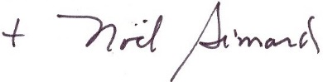

Noël Simard
Bishop of Valleyfield
