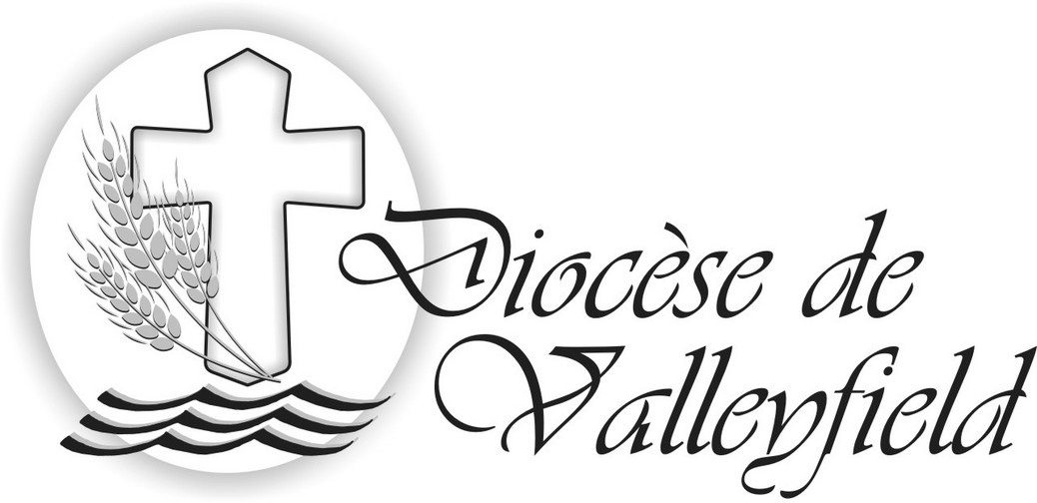

125th ANNIVERSARY OF THE FOUNDING
OF THE DIOCESE OF VALLEYFIELD

HERITAGE ─ PRESENCE ─ HOPE

TO ALL DIOCESAN MEMBERS
SALUTATIONS AND BLESSINGS IN THE LORD

The Mass of Chrism will take place on Tuesday, April 11 at 7:30pm in Saint Cecile’s Cathedral-Basilica in Salaberry-de-Valleyfield. In this, the 125th Anniversary of the founding of our diocese, it will be a particularly festive occasion.

I warmly invite all our Diocesan Church to participate at this Mass of Chrism: the faithful, our catechists, our pastoral agents and, of course, our deacons and priests. A large participation at this liturgy shows to advantage the unity of the diocesan community surrounding their Bishop.

The Mass of Chrism is primarily a ritual Mass at which the Holy Chrism is consecrated and the oil of the sick and the oil of the catechumens are blessed. However, Blessed Pope Paul VI wanted to have a concelebrated Mass to commemorate the institution of the priesthood: that is why the renewal of priestly vows is included. Moreover, the opening prayer elaborates on the sense of this Mass: «Because you have consecrated us in Him (Christ), make us witnesses of the Gospel of salvation to the world». Here we find the sense of belonging of the faithful People of God and of our common mission to proclaim the Gospel of Christ.

This year’s Mass of Chrism will be profoundly marked by the celebration of the 125th Anniversary of the founding of our diocese. In the presence of His Excellency Mgr Luigi Bonazzi, the Apostolic Nuncio for Canada, we will render grace for the heritage of faith which constitutes these 125 years. Well-rooted in our presence today, and looking to the many challenges in our future, we resolve to accept the missionary shift, in hope.

Therefore, I am waiting to welcome you on Tuesday, April 11 at 7:30pm in our beautiful cathedral. Together, let us take this opportunity to renew the missionary commitment given to us at baptism. May this renewal invigorate our faith and stimulate our fervour to go out and be beacons of light, who guide the men and women of our time, and give them the desire to navigate towards God our Father, in Jesus and through the Holy Spirit, who waits to serve them the bread of His love and His Word.
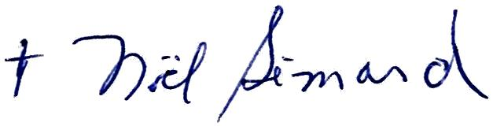

Prot. N° 19/17
February 2017 Noël Simard
Bishop of Valleyfield

